| Experiment No.6 |
| --- |
| Perform POS tagging on the given English and Indian Language Text |
| Date of Performance: |
| Date of Submission: |

**Aim:** Perform POS tagging on the given English and Indian Language Text

**Objective:** To study POS Tagging and tag the part of speech for given input in english and an Indian Language.

**Theory:**

The primary target of Part-of-Speech (POS) tagging is to identify the grammatical group of a given word. Whether it is a NOUN, PRONOUN, ADJECTIVE, VERB, ADVERBS, etc. based on the context. POS Tagging looks for relationships within the sentence and assigns a corresponding tag to the word.

**POS Tagging** (Parts of Speech Tagging) is a process to mark up the words in text format for a particular part of a speech based on its definition and context. It is responsible for text reading in a language and assigning some specific token (Parts of Speech) to each word. It is also called grammatical tagging.

**Steps Involved in the POS tagging example:**

* Tokenize text (word_tokenize)
* apply pos_tag to above step that is nltk.pos_tag(tokenize_text)

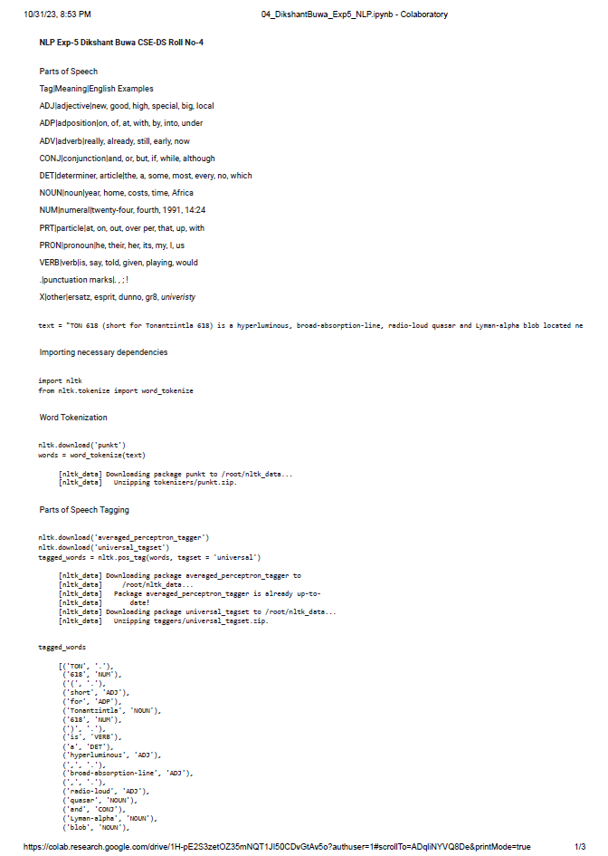

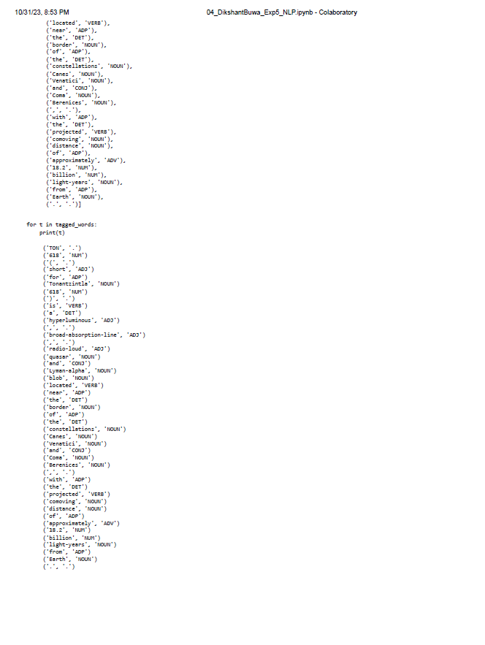

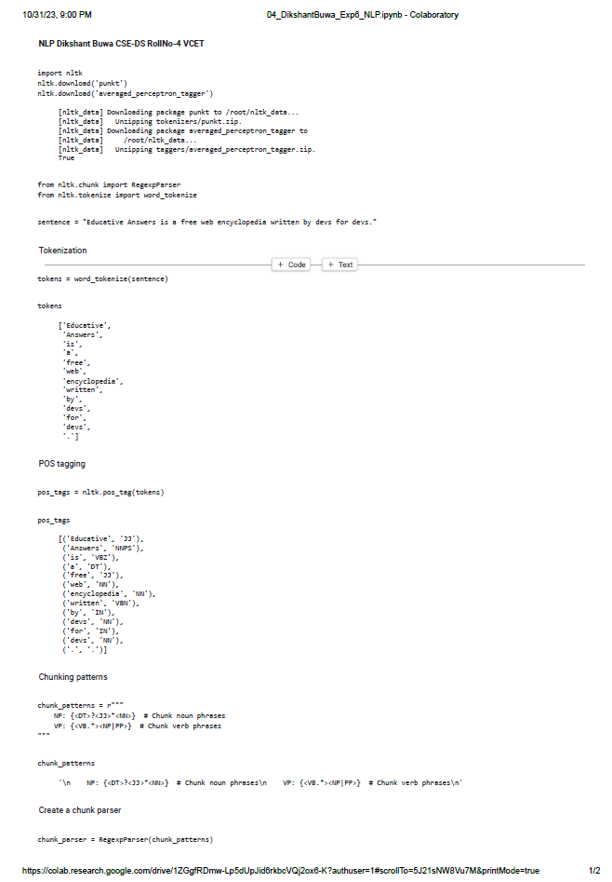



**Conclusion:**

The results of part-of-speech (POS) tagging can significantly impact natural language processing tasks, and various techniques have been developed to tackle this problem. Rule-based methods use predefined patterns and heuristics, providing transparency but often lacking accuracy. Statistical methods, such as Hidden Markov Models and Conditional Random Fields, utilize probabilistic models to achieve better accuracy. Machine learning approaches, including deep learning models like recurrent neural networks (RNNs) and transformers, have recently demonstrated state-of-the-art performance by learning contextual information. In conclusion, the choice of POS tagging technique should consider the trade-off between accuracy and complexity, with machine learning methods offering the most promising results in recent years, especially when trained on large datasets and taking advantage of contextual information.